**E115 – Programming and Data Analysis**

**Practice questions for Week 03**

**Functions and Subroutines**

1. Which of the following function declarations is correct for the subroutine shown below?

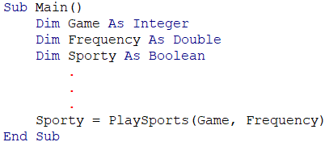

1. Function Sporty(Game as Integer, Frequency as Double) as Boolean
2. Function PlaySports (G as Integer, F as Double) as Boolean
3. Function Game (PlaySports as Boolean, Sporty as Boolean) as Integer
4. Function PlaySports (Frequency as Double, Game as Integer) as Boolean
5. Study the subroutine “Main” as shown below.



Write a subroutine named “Rect_Area” that will calculate the area of the rectangle with the dimensions that are passed to it by “Main”, and display the result in a message box.

1. Study the subroutine “Main” as shown below.

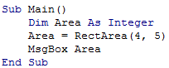

Write a function named “Rect_Area” that will calculate the area of the rectangle with the dimensions that are passed to it by “Main”, and return the result to the calling subroutine “Main”.

1. Study the subroutine “Main” as shown below.



Write a function named “CircleArea” that will calculate the area of the circle with the radius that is passed to it by “Main” and return the result to the calling subroutine “Main”.